😃 Class 7
Good morning, Milena,
Welcome to your seventh English class. I hope you're having a beautiful day. Today we’ll explore one of the most powerful activities of the course, a challenge that blends storytelling, emotional intelligence, and professional fluency. The purpose is to help you develop a more natural, expressive, and emotionally grounded use of English, especially when narrating lived experiences from the perspectives of others.
To begin, you will listen to four different types of voices and realities. These are the perspectives of Afro-Colombian and Indigenous women, expressed through two distinct emotional tones: one filled with pride, joy, and strength; the other shaped by pain, exhaustion, and invisibility. You will explore both emotional registers to better understand how narrative tone shapes the message.
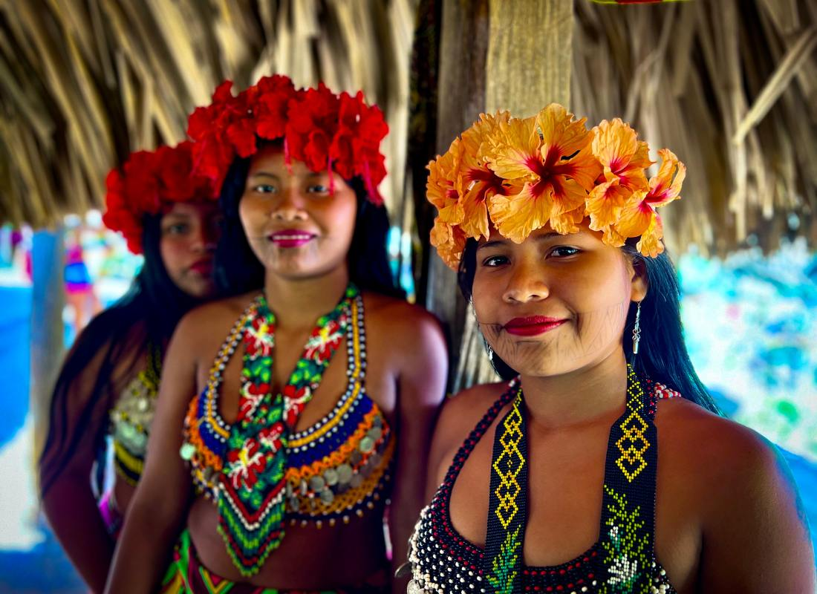

1. Afro-Colombian Woman (Emotional and Empowering) – Yurani Mosquera
My name is Yurani Mosquera. I am an Afro-Colombian woman from Pueblo Rico, Risaralda. I live in a small community surrounded by mountains, where the mornings are filled with music from the birds and the smell of wood fire. Every day I wake up with gratitude. I stretch, I smile, and I thank my ancestors for the life I have.
By 5 a.m., I’m already cooking for my family. While the coffee boils, I’m thinking about how to teach my children to love who they are. I tell them that their curly hair is a crown, their skin is beautiful, and their history is powerful. I want them to know they can speak up, ask questions, and lead with pride.
During the day, I help in the community. Sometimes I translate for elders at the health center. Sometimes I help organize local meetings. I listen to other women, I learn from them, and we remind each other that our voices matter. I’ve realized that leadership is not about titles. It’s about care. It’s about showing up, even when it’s hard.
As a Black woman, I know there are challenges. But I don’t let them define me. I’ve learned to walk with my head high. I’ve learned that joy is also resistance. Dancing, singing, and sharing stories with other women is part of our strength.
I dream of a Pueblo Rico where our daughters grow up feeling proud, where they don’t have to ask for permission to lead. Until then, I will keep showing them how it’s done. With love, with joy, with fire in my heart.

2. Indigenous Embera Woman (Emotional and Empowering) – Daira Guasiruma
My name is Daira Guasiruma. I am an Embera Chamí woman. I live in Santa Cecilia, close to the forest, where the trees speak and the rivers remember. When I wake up, I feel the earth under my feet and the energy of my ancestors around me.
I start the day preparing food for my children. I grind corn, make bejuco soup, and collect medicinal plants from our garden. I sing songs in Embera while I work, songs my grandmother taught me about where we come from. They remind me that being a woman here is a gift. We give life. We protect life.
Even though it's not always easy, I feel proud. I have dreams of learning more, of sharing what I know, of connecting with women from other communities. Sometimes I walk for hours to attend a workshop or a health talk. It’s tiring, but I do it with love. I want to grow, to lead, to speak for the women in my community who are still too shy to raise their voices.
I know that sometimes I need permission to leave my house. I know that the meetings are in Spanish, and I’m still learning. But I go anyway. Because I believe in myself. I believe in the power of the words I carry. My voice is not loud, but it is strong. It holds the wisdom of my people and the dreams of my daughters.
I want the world to know that we, Embera women, are ready. Ready to learn, ready to lead, and ready to create a better future with our hands, our hearts, and our songs.

3. Afro-Colombian Woman (Raw and Painful) – Yurani Mosquera
My name is Yurani Mosquera and I’m tired. I’m tired of always having to prove that I belong in places where my voice is not heard. I wake up at 4:30 in the morning, cook for my children, clean the house, take care of my mother, and still try to find time to be a leader. But most days, I don’t feel like one.
I go to meetings where no one looks like me, where my ideas are dismissed. I try to speak up, but people interrupt. They talk over me. They act like I’m not there. Being an Afro-Colombian woman means carrying the weight of my ancestors, while still being invisible.
I see how others get support, get training, get recognition. And I ask myself, what about us? What about our voices? What about our dreams? Sometimes I cry in silence, because being strong all the time is exhausting.
But I keep going. Not because it's easy, but because my daughter is watching. Because I want her to believe she can do anything, even when the world tells her otherwise. I wish I didn’t have to fight this hard just to be seen.

4. Indigenous Embera Woman (Raw and Painful) – Daira Guasiruma
My name is Daira Guasiruma and today I feel alone. I feel unheard. I wake up before the sun rises, cook, clean, care for my children, tend to the garden, and then ask my husband if I’m allowed to go to a meeting. Sometimes he says no. Sometimes the governor says no. And even when I go, I don’t always understand the Spanish.
I sit in a room full of people talking fast, using words I don’t know, while I hold back my thoughts because I’m afraid they’ll laugh or ignore me. I want to share what I know. I want to talk about plants, about healing, about how we care for each other. But I stay quiet.
Being a woman in my community means you have to ask for everything. Permission to speak. Permission to leave. Permission to dream. And still, they say we don’t participate enough.
Some days I ask myself, what’s the point? Why try if they don’t see us? If they don’t listen? But then I remember my grandmother, and how she taught me to sing to the river and listen to the forest. That is knowledge too. That is leadership too.
Even in my silence, I carry strength. But I wish I didn’t have to carry it alone.

After that, you’ll move into the main activity. Here's what you’ll do:
You will imagine yourself fully in the place of four different women, one Afro-Colombian and one Indigenous. For each identity, you will create and speak two full narratives: one joyful and one painful.
That means you will create four separate narratives in total:
- A happy Afro-Colombian woman
- A sad Afro-Colombian woman
- A happy Indigenous woman
- A sad Indigenous woman
For each narrative, you will describe her day in full detail, from the moment she wakes up in the morning to the moment she falls asleep at night. As you speak, focus not just on what happens but on how it feels. Speak with her voice, her emotions, her rhythm, and her cultural grounding. Your task is to go beyond imagination and speak from within her lived experience.
This activity will allow you to:
- Practice using emotional vocabulary and tone
- Develop fluency through immersion in different realities
- Strengthen your ability to narrate complex, human-centered stories in English
- Build professional storytelling skills with empathy and depth
Let’s begin when you're ready.

Equitable Community Participation in Pueblo Rico, Colombia
Since 2019, health initiatives have been implemented in the municipality of Pueblo Rico, Risaralda, Colombia, where limited participation of Indigenous and Afro-Colombian women was identified. For this reason, a research project was carried out to understand how the intersection of gender, ethnicity, age, and place of residence affects equitable participation in social innovation initiatives in health. This video is one of the results of that research. It was created through a co-creation process with the community of Pueblo Rico, using the stop-motion animation technique.
During an audiovisual workshop, participants identified and portrayed the factors that influence equitable participation in health. The images and scenes include elements from their own cultures, highlighting the three cultural groups in Pueblo Rico: Mestizo, Indigenous, and Afro-Colombian; the natural environment they live in; and the importance of medicinal plants and ancestral knowledge. In their representations of rivers and birds, they used a traditional Indigenous beading technique known as Shakiras, and they chose a song in the Embera language that describes the origin of the Embera people, their spiritual beliefs, and the role of ancestral medicine. Have you ever thought about the obstacles a person might face when trying to become a health leader in Pueblo Rico?
High costs and long travel times from rural areas, health programs delivered in Spanish when not everyone speaks or reads it. Women leaders must also balance domestic responsibilities and childcare, have less decision-making autonomy, and receive less recognition from their communities.
"For Embera Indigenous women, it is hard to be a leader because we have to ask for permission from our husbands and the community governor to attend a meeting or training, and sometimes they don’t give us permission."
"For Indigenous women, it’s difficult to be a leader because we are shy, we struggle economically, and some of us don’t speak Spanish."
We need more trainings where we can exchange ideas with Afro-Colombians, Mestizos, and others, including institutions and organizations.
And what about the organizations?
For Indigenous people, it’s harder to be a leader. There is less education, less work, and very few receive a salary. The difference between being a man and being a woman is big. Why? Because women carry a bigger burden. Women must care for the children, cook the meals. We also have gardens to take care of, and all the horticulture. So men often say, "If there’s a meeting and either the man or the woman must go, well, you know you have the kids, you know you have to cook while I’m gone."
Afro-Colombian women also face difficulties in becoming leaders due to the lack of community support, and especially because of the lack of empowerment and confidence in ourselves.
Equity is about being at peace.
Men and women guide each other. The participation of women in health is important because of their experience and knowledge in caring for their families, especially children. Gender equity is important so that both men and women can have the same knowledge, lead by example, learn, and share what they know with the community, giving presentations as women leaders.
This video seeks to represent the community’s perspective on the factors that influence equitable participation in health initiatives.
While it does not present the full findings of the research, the goal is to represent and share these insights in a way that contributes to greater inclusion in future health initiatives. We hope this helps improve participation from underrepresented groups and fosters a broader impact in the community. Thank you for watching this video.
Key Points List
- Structural barriers to equitable participation
- Overload of roles for women
- Gender inequality and lack of recognition
- Need for empowerment and training
- Equity as a foundation for peace and community well-being
Key Points Explained
1. Structural barriers to equitable participation
Indigenous and Afro-Colombian women face multiple obstacles, such as high transportation costs and long travel times from rural areas, language barriers (as many programs are only in Spanish), and limited autonomy. Some need permission from husbands or community leaders to attend meetings or trainings, which often prevents their participation in health initiatives.
2. Overload of roles for women
Women carry multiple responsibilities including childcare, cooking, home gardens, and household duties. These burdens limit their availability and ability to take on leadership roles, especially when compared to men, who are more likely to be free to attend meetings and trainings.
3. Gender inequality and lack of recognition
Women receive less recognition and support within their communities. They have fewer opportunities for education, employment, and financial independence. Cultural expectations and social norms further restrict their leadership potential, often making them feel shy or unprepared.
4. Need for empowerment and training
There is a strong call from the community for more spaces for training, dialogue, and exchange, especially between Indigenous, Afro-Colombian, and Mestizo groups, and with institutions. These spaces are seen as essential for building confidence, leadership skills, and solidarity among women.
5. Equity as a foundation for peace and community well-being
The community expresses that gender equity means peace, mutual guidance, and shared knowledge between men and women. Valuing women’s experience in health and family care strengthens collective well-being and ensures more inclusive and impactful health initiatives.
QUESTIONS
- During the co-creation process, did any internal tensions or resistance emerge within the community regarding women’s leadership?
- How does the structure of local government or health institutions influence women’s ability to access spaces for participation?
- What role do ancestral knowledge systems play in community decision-making around health and leadership?
- What are the implications of many women not speaking Spanish when it comes to interacting with the state or health-related programs?
- Did you observe any transformation in gender dynamics or perceptions of female leadership as a result of the participatory process?
- What were the most important methodological lessons from working through an intercultural and participatory research approach?
- What strategies could be effective in fostering collective (rather than individual) leadership in communities with strong traditional structures?
- What role do men play in building equitable participation? Were they involved in this process in any way?
- How can cultural expressions like Embera-language music or Shakira beadwork be integrated into public policy or formal health programs?
- Do you think the video, as a tool for intercultural communication, can influence decision-makers? How can we ensure it doesn’t remain purely symbolic?

Participación comunitaria equitativa en Pueblo Rico, Colombia
Durante las iniciativas en salud implementadas en el municipio de Pueblo Rico, Risaralda, Colombia, desde el 2019, se identificó una limitada participación de mujeres indígenas y afrocolombianas. Por tal razón, se desarrolló una investigación con el fin de comprender cómo la intersección entre género, etnia, edad y lugar de residencia afecta la participación equitativa en las iniciativas de innovación social en salud. Este video es uno de los resultados de esta investigación. Este video es el resultado de un ejercicio de co-creación con la comunidad de Pueblo Rico utilizando la técnica de animación Stop Motion.

Durante un taller audiovisual, los participantes identificaron y representaron los factores que afectan la participación equitativa en salud. Las imágenes y escenas incluyen elementos propios de su cultura, resaltando las tres culturas de Pueblo Rico: mestiza, indígena y afrocolombiana; el entorno natural en el que viven; y la importancia de las plantas y las medicinas ancestrales.
En sus representaciones de ríos y pájaros, usaron una técnica indígena de joyería en Shakiras, y seleccionaron la canción en lengua embera que describe el origen del pueblo embera, sus creencias espirituales y la labor de la medicina ancestral.
¿Has pensado qué obstáculos enfrenta una persona para ser líder en salud en Pueblo Rico?

Alto costo y largo tiempo de transporte desde las zonas rurales, programas en español y no todos lo hablan o lo leen. A las lideresas se les suman las labores del hogar y el cuidado de los niños, menos autonomía en la toma de decisiones, menos reconocimiento de su comunidad.
“Para la mujer indígena embera es difícil ser lideresa porque tenemos que pedir permiso al esposo y al gobernador para poder ir a un encuentro o una capacitación y a veces no nos dan permiso.”
“Para la mujer indígena es difícil ser lideresa porque somos tímidas y por la economía y algunas no hablan español.”
Necesitamos más capacitaciones para intercambiar ideas con afros, paisas y otros, instituciones y organizaciones.

¿Y las organizaciones?
Para los indígenas, es más difícil ser líder, porque hay menos estudio, menos trabajo, y muy pocos reciben salario.
Bueno, la diferencia entre ser hombre y ser mujer es grande. ¿Por qué? Porque la mujer tiene un papel más grande. La mujer tiene que cuidar a los hijos, preparar la comida. También tenemos las huertas alrededor, la horticultura, todo eso. Entonces, los hombres al menos dicen: si vamos a una reunión y le toca a la mujer o al hombre, uno ya sabe que tiene los hijos, que tiene que preparar la comida mientras ellos se van.
Las mujeres afro también enfrentan dificultades para ser lideresas por la falta de apoyo de la comunidad, y sobre todo por la falta de empoderamiento y de confianza en nosotras mismas.

Equidad se trata de estar en paz.
Entre hombres y mujeres nos orientamos entre nosotros. La participación de mujeres en salud es importante por su experiencia y conocimiento en el cuidado de la familia y sobre todo con los niños.
La equidad de género es importante para que tanto hombres como mujeres tengan el mismo conocimiento y den buen ejemplo, aprendan y den conocimiento en la comunidad haciendo presentaciones como lideresas.

Este video busca representar la perspectiva de la comunidad sobre factores que influyen en la participación equitativa en las iniciativas de salud.
Si bien no ilustra los resultados de toda la investigación, se espera que representar y difundir estos factores a través de este formato pueda contribuir a la inclusión en futuras iniciativas de salud, facilitando la participación de grupos de población con menor representación y produciendo un impacto comunitario más amplio.
Gracias por ver este video.

Storytelling 1
I am Ritalina Restrepo, I am 35 years old and I’m leader for women in my community, I love work for women, I belief that better future for all is possible if we work together, I dream a day that the Embera women can study and learn like as paisas women, and we can lead process in our community. I hope our voices to be listened.
Sometimes working for the communities is a challenge because of the household chores and also because there are husbands who don´t allow their wives to be leaders. I have five children, 2 men and 3 women, fortunately my children and my husband support me to be leader. When I’m busy working for the community, my older children look after the younger ones, and the women of my community sometimes help me with the household chores, and always I have the permission and support of my husband. He knows that I work to build a better future for our children, in particular, for our daughters.

Storytelling 2
My name is Doliria Cheche, I’m 35 years old, I would like to study and to be a great leader in my community. But really, the life for the embera women is very difficult, we need a permission of our husband and our governor to participate in any meeting. Additionally, is difficult for us to study, because the school are very far, usually the study are for men, no for women. For this reason, our Spanish isn’t very good, and it’s difficult for us understand a lot of things.
However, the most bigger limitation for us for to be leader, is that traditionally we have big families. My grandmother and my mother had 9 children, and my case is similar. I had my first children when I was fourteen years old, and I had to stop to study. Now, I have other five more children, and it’s very difficult participate in community work, I have to take care my family, and I prefer avoid problems with my husband. However, I hope that my daughters have a better future for them, and they can change the tradition of the embera women.

